# QUESTION # 1

**#include <iostream>**

**using namespace std;**

**int main ()**

**{**

**int A[10],max=INT_MIN,min=INT_MAX,ix=0,in=0;**

**for (int a=0;a<10;a++)**

**{**

**cout << "Enter : ";cin>>A[a];cout<<endl;**

**}**

**for (int a=0;a<10;a++)**

**{**

**if (max<A[a])**

**{**

**max=A[a];**

**ix=a;**

**}**

**if (min>A[a])**

**{**

**min=A[a];**

**in=a;**

**}**

**}**

**cout <<"Maximum Value is : "<<max <<" at index "<< ix<<endl;**

**cout <<"Minimum Value is : "<<min <<" at index "<< in<<endl;**

**return 0;**

**}**

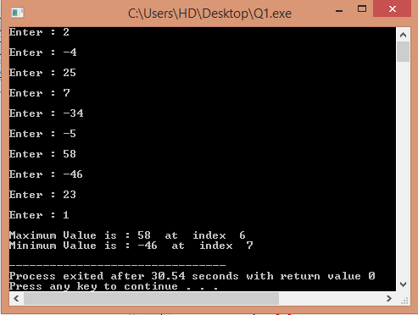

# QUESTION # 2

**#include <iostream>**

**using namespace std;**

**int main()**

**{ float A[10],s=0;**

**for(int a=0;a<10;a++)**

**{**

**cout <<a+1<< " Enter : ";cin>>A[a];cout<<endl;**

**s+= A[a]; }**

**cout << "SUM is : "<<s <<endl<<endl;**

**cout << "Average is : "<< s/10<<endl;**

**return 0;}**

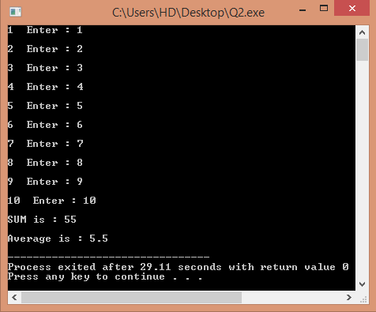

# QUESTION #3

**#include <iostream>**

**using namespace std;**

**float sum(float[10]);**

**int main()**

**{**

**float A[10],s;**

**s = sum(A);**

**cout << "Sum is : "<<s<<endl;**

**return 0;**

**}**

**float sum(float s[10])**

**{**

**float b=0;**

**for (int a=0;a<10;a++)**

**{**

**cout<<a+1 << " Enter : ";cin>>s[a];**

**b+=s[a];**

**}**

**return b;**

**}**

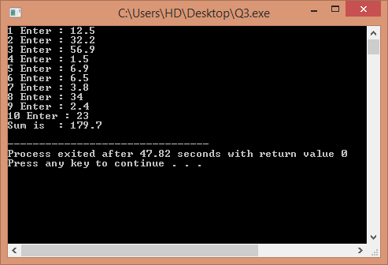

# QUESTION # 4

**#include <iostream>**

**using namespace std;**

**int main ()**

**{**

**const int m=3,d=4;**

**double s[d][m];**

**for (int a=0;a<d;a++)**

**{**

**cout << "District :: "<<a+1<<endl;**

**for (int b=0 ;b<m;b++)**

**{**

**cout << b+1 << " Month : ";cin>>s[a][b];**

**}**

**}**

**cout <<"\t\t" <<"Month"<<endl;**

**cout << "\t\t 1\t2\t3"<<endl;**

**for (int a=0;a<d;a++)**

**{**

**cout << "District "<<a+1<<'\t';**

**for (int b=0 ;b<m;b++)**

**{**

**cout << s[a][b]<<"\t";**

**}**

**cout <<endl;**

**}**

**return 0;**

**}**

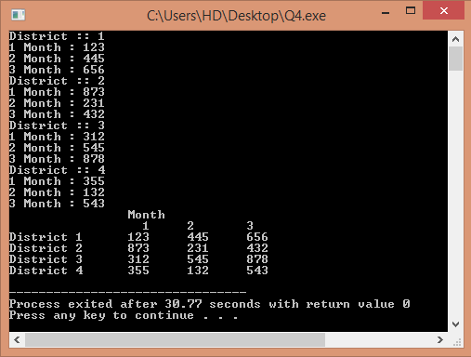

# QUESTION # 5

**#include <iostream>**

**#include <math.h>**

**using namespace std;**

**int main()**

**{**

**int a =-29;**

**int b = 5 ;**

**int d = 0 ;**

**float c=7.52;**

**cout << "Square root of "<< b <<" : "<< sqrt(b)<< endl;**

**cout << "Absolute value of "<< a << " : "<< abs(a)<< endl;**

**cout << "Power (2) of "<< c << " : "<< pow(c,2)<< endl;**

**cout << "Power (4) of "<< b << " : "<< pow(b,4)<< endl;**

**cout << "Sin value of "<< c << " : "<< sin(c)<< endl;**

**cout << "Cos value of "<< d << " : "<< cos(d)<< endl;**

**cout << "Tangent value of "<< b << " :"<< tan(b)<< endl;**

**return 0;**

**}**

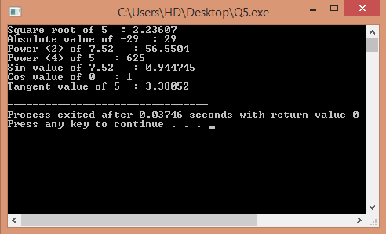

# QUESTION #6

**#include <iostream>**

**#include <math.h>**

**double area (float);**

**using namespace std;**

**int main()**

**{**

**float r;**

**cout << "Enter the radius : ";cin>>r;**

**cout << "Area of Circle is : "<< area(r)<<endl;**

**return 0;**

**}**

**double area (float c)**

**{**

**double a;**

**a = pow(c,2)*3.1416;**

**return a;**

**}**

